**ADVANCE EXCEL ASSIGNMENT - 16**

**1. What is a Macro? How is it useful in excel or in your daily work?**

A macro is a set of instructions used to execute repetitive tasks. If you have tasks in Microsoft Excel that you do repeatedly, you can record a macro to automate those tasks. A macro is an action or a set of actions that you can run as many times as you want. When you create a macro, you are recording your mouse clicks and keystrokes.

**2. What is VBA? Write its full form and briefly explain why VBA is used in**

**excel?**

**Visual Basic for Applications** is a computer programming language developed and owned by Microsoft. With VBA you can create macros to automate repetitive word- and data-processing functions, and generate custom forms, graphs, and reports.

**3. How do you record a macro? Write detailed steps to create a macro to**

**automatically make the following table in bold and to create borders for**

**it in excel.**

Here are the steps to record this macro:

1. Click the Developer tab.
2. 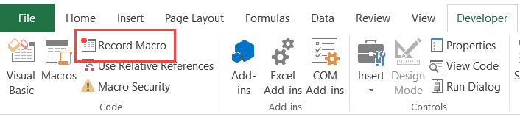In the Code group, click on the Macro button. This will open the ‘Record Macro’ dialog box.
3. In the Record Macro dialog box, enter a name for your macro. I am using the name **EnterText**. There are some naming conditions that you need to follow when naming a macro. For example, you cannot use spaces in between. I usually prefer to keep my macro names as a single word, with different parts with a capitalized first alphabet. You can also use underscore to separate two

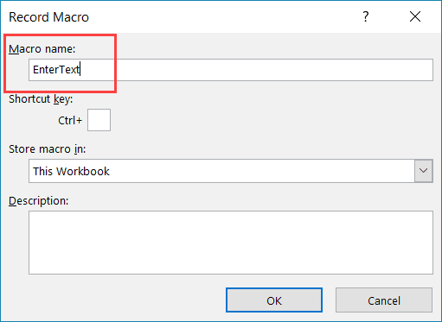words – such as EnterText.

1. 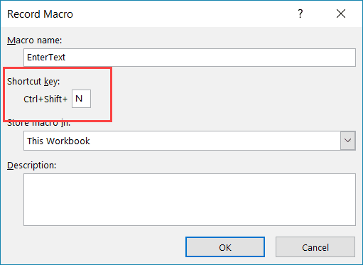(Optional Step) You can assign a keyboard shortcut if you want. In this case, we will use the shortcut Control + Shift + N. Remember that the shortcut you assign here would override any existing shortcuts in your workbook. For example, if you assign the shortcut Control + S, you will not be able to use this for saving the workbook (instead, every time you use it, it will execute the macro).
2. 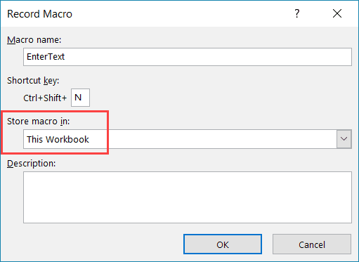In the ‘Store macro in’ option, make sure ‘This Workbook’ is selected. This step ensures that the macro is a part of the workbook. It will be there when you save it and reopen again, or even if you share it with someone.
3. (Optional Step) Enter a description. I usually don’t do this, but if you’re extremely organized, you may want to add what the macro is about.
4. Click OK. As soon as you click OK, it starts to record your actions in Excel. You can see the ‘Stop recording’ button in the Developer tab, which indicates that the macro recording is in progress.
5. Select cell A2.
6. Enter the text Excel (or you can use your name).
7. Hit the Enter key. This will select cell A3.
8. Click on the Stop Recording button the Developer tab.

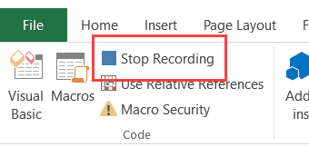

Follow the steps below to test the macro:

Delete the text in cell A2. This is to test if the macro inserts the text in cell A2 or not.

Select any cell – other than A2. This is to test whether the macro selects cell A2 or not.

Click the Developer tab.

In the Code group, click the Macros button.

In the Macro dialog box, click on the macro Name – EnterText.

1. 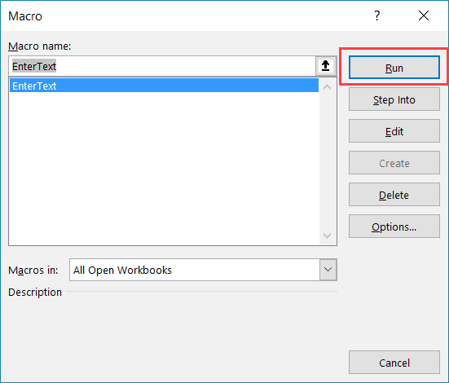Click the Run button.

You will notice that as soon as you click the Run button, the text ‘Excel’ gets inserted into cell A2 and cell A3 gets selected.

Now, this may all happen in a split second, but in reality, the macro  – just like an obedient elf – followed the exact steps you showed it while recording the macro.

So the macro first selects the cell A2, then enters the text Excel in it, and then selects the cell A3.

**4. What do you mean when we say VBA Editor?**

Visual Basic Editor is a separate application that is a part of Excel and opens whenever you open an Excel workbook. By default, it’s hidden and to access it, you need to activate it.

VB Editor is the place where you keep the VB code.

There are multiple ways you get the code in the VB Editor:

1. When you [record a macro](https://trumpexcel.com/record-macro-vba/), it automatically creates a new module in the VB Editor and inserts the code in that module.
2. You can manually type VB code in the VB editor.
3. You can copy a code from some other workbook or from the internet and paste it in the VB Editor.

**5. Briefly describe the interface of a VBA editor? What are properties**

**window? And what is watch window? How do you** **display these**

**windows?**

The Visual Basic Editor is not exactly the same as Excel. It is actually a separate application, even though you'll usually open it through Excel. In fact, in order for the VBE to be able to run, Excel must be open.

The main function of the VBE is to allow you to write and edit VBA code.

The Visual Basic Editor is sometimes referred to as the Integrated Development Environment (IDE). In this Excel tutorial, I use the first term (Visual Basic Editor or VBE) but don't be confused if you see the second term being used in other places.

* The Properties window lists the design-time properties for selected objects and their current settings. You can change these properties at design time. When you select multiple controls, the Properties window contains a list of the properties common to all the selected controls.
* To navigate the Properties window
* From the View menu of the Visual Basic Editor, choose Properties window (F4).
* Select the object whose properties you want to display. You can either use the mouse to select the object or use the Project Explorer to choose from a list.
* Click the Alphabetic tab to display properties in alphabetic order, or choose the Categorized tab to display object properties by category.

The **Watch Window** makes it convenient to inspect, audit, or confirm formula calculations and results in large worksheets. By using the Watch Window, you don't need to repeatedly scroll or go to different parts of your worksheet. This toolbar can be moved or docked like any other toolbar.

**6. What is an immediate Window and what is it used for?**

The Immediate window displays information resulting from debugging statements in your code or from commands typed directly into the window. From the View menu, choose Immediate window (CTRL+G).